JAVA Assingment – 01

Last Date of submission :- 04-09-23

1. To print an integer entered by the user:
2. importjava.util.Scanner;
3. publicclass integer {
4. publicstaticvoidmain(Stringargs[]) {
5. System.out.print("ASHISH PATIDAR\nROLL NO. 0827CI221034\n");
6. System.out.println("Enter any integer");
7. try (Scanner sc =newScanner(System.in)) {
8. int integer =sc.nextInt();
9. System.out.println("The entered integer is: "+ integer);
10. }
11. }
12. }

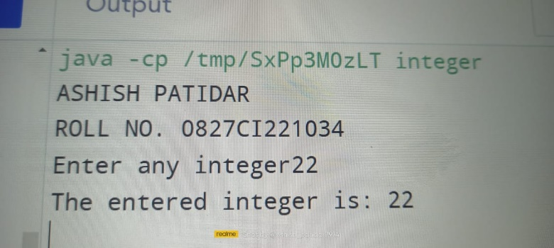

2. Write a program to demonstrate the usage of primitive data types—Boolean, char, byte, short, Int, long, float and double:-

publicclassall_opert{

    publicstaticvoidmain(String[] args) {

        System.out.println("\nASHISH PATIDAR\n ROLL NO. 0827CI221034");

*// Boolean data type*

        booleanisJavaFun=true;

        System.out.println("In Java boolean data types \n "+isJavaFun);

*// Char data type*

        char grade ='A';

        System.out.println("\nMy grade is: "+ grade);

*// Byte data type*

        bytebyteValue=127;

        System.out.println("\nByte value: "+byteValue);

*// Short data type*

        shortshortValue=32000;

        System.out.println("\nShort value: "+shortValue);

*// Int data type*

        intintValue=123456;

        System.out.println("\nInt value: "+intValue);

*// Long data type*

        longlongValue=1234567890L;

        System.out.println("\nLong value: "+longValue);

*// Float data type*

        floatfloatValue=3.14f;

        System.out.println("\nFloat value: "+floatValue);

*// Double data type*

        doubledoubleValue=3.14159265359;

        System.out.println("\nDouble value: "+doubleValue);

}

}

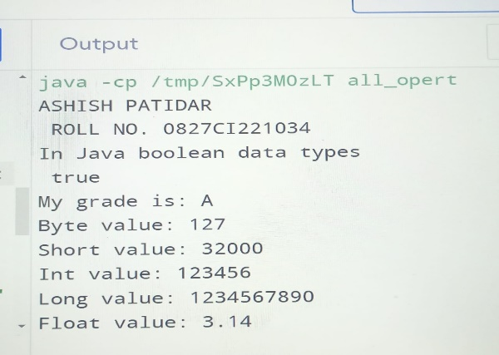

3. Swapping two numbers using temporary variable:-

importjava.util.Scanner;

publicclass swap {

    publicstaticvoidmain(Stringargs[]) {

        System.out.println("\nASHISH PATIDAR\n ROLL NO. 0827CI221034");

        Scanner sc =newScanner(System.in);

        System.out.println("Enter the number 1  :");

        int a =sc.nextInt();

        System.out.println("Enter the number 2  :");

        int b =sc.nextInt();

        inttmp;

        tmp= a;

        a = b;

        b =tmp;

        System.out.println("The swapped numbers are:\n"+ a +"\t"+"and"+"\t"+ b);

    }

}

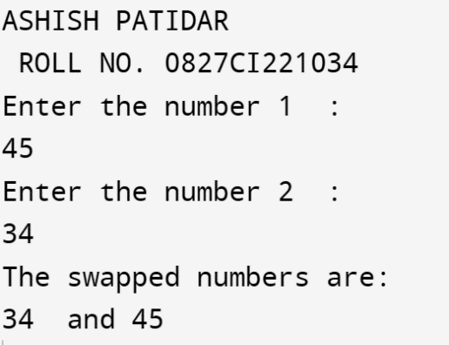

4.Check whether a number is even or odd using if..else statement:-

importjava.util.Scanner;

publicclasseven_od{

    publicstaticvoidmain(Stringargs[]) {

        System.out.println("\nASHISH PATIDAR\n ROLL NO. 0827CI221034");

        System.out.println("Enter any number: ");

        Scanner sc =newScanner(System.in);

        int num =sc.nextInt();

        if (num %2==0) {

            System.out.println("The number ["+ num +"] is even.");

        } else {

            System.out.println("The number ["+ num +"] is odd");

        }

    }

}

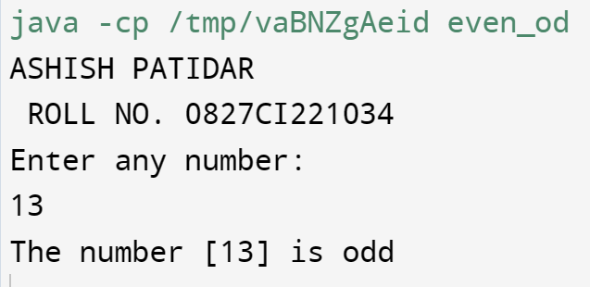

5. Check whether an alphabet is a vowel or a consonant using if…else statement:-

importjava.util.Scanner;

publicclass vowel {

    publicstaticvoidmain(Stringargs[]) {

        System.out.println("\nASHISH PATIDAR\n ROLL NO. 0827CI221034");

        System.out.println("Enter any alphabet: ");

        try (Scanner sc =newScanner(System.in)) {

            charch=sc.next().charAt(0);

            if (ch=='a'||ch=='e'||ch=='i'||ch=='o'||ch=='u') {

                System.out.println("The entered alphabet ["+ch+"] is a vowel.");

            } elseif (ch=='A'||ch=='E'||ch=='I'||ch=='O'||ch=='U') {

                System.out.println("The entered alphabet ["+ch+"] is a vowel.");

            } else {

                System.out.println("The entered alphabet ["+ch+"] is aconsonant.");

            }

        }

    }

}

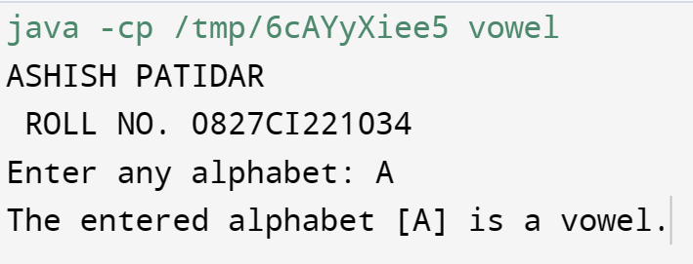

6. Check if a number is positive or negative using if..else.

public class PositiveNegative {

public static void main(String[] args) {

System.out.println("\nASHISH PATIDAR\n ROLL NO. 0827CI221034\n");

double number = 12.3;

// true if number is less than 0

if (number < 0.0)

System.out.println(number + " is a negative number.");

// true if number is greater than 0

else if ( number > 0.0)

System.out.println(number + " is a positive number.");

// if both test expression is evaluated to false

else

System.out.println(number + " is 0.");

}

}

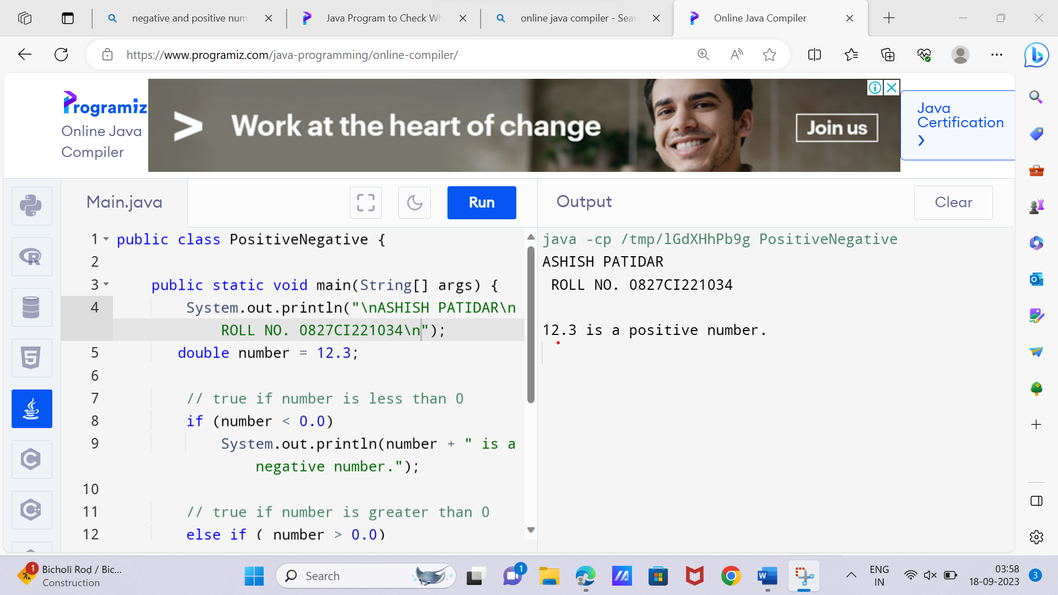

7. Sum of natural numbers using for loop:-

importjava.util.Scanner;

publicclasssum_of_num{

    publicstaticvoidmain(Stringargs[]) {

        System.out.println("\nASHISH PATIDAR\n ROLL NO. 0827CI221034");

        System.out.println("Enter number of terms: ");

        try (Scanner sc =newScanner(System.in)) {

            int n =sc.nextInt();

            int sum =0;

            for (inti=0; i<= n; i++) {

                sum +=i;

            }

            System.out.println("The sum is "+ sum);

        }

    }

}

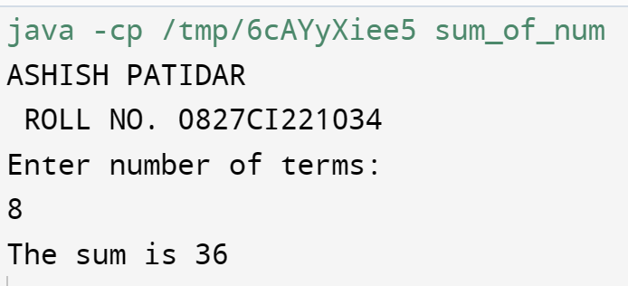

8. Find factorial of a number using for loop:-importjava.util.Scanner;

publicclass factorial {

    publicstaticvoidmain(Stringargs[]) {

        System.out.println("\nASHISH PATIDAR\n ROLL NO. 0827CI221034");

        System.out.println("Enter number of terms: ");

        try (Scanner sc =newScanner(System.in)) {

            int n =sc.nextInt();

            int fact =1;

            for (inti=1; i<= n; i++) {

                fact *=i;

            }

            System.out.println("The factorial is "+ fact);

        }

    }

}

9. Generate multiplication table using for loop:-

importjava.util.Scanner;

publicclass table {

    publicstaticvoidmain(Stringargs[]) {

        System.out.println("\nASHISH PATIDAR\n ROLL NO. 0827CI221034");

        System.out.println("Enter the number whose table you want to print:");

        try (Scanner sc =newScanner(System.in)) {

            int num =sc.nextInt();

            for (inti=1; i<=10; i++) {

                System.out.println(num +" "+"*"+" "+i+" "+"="+ num *i);

            }

        }

    }

}

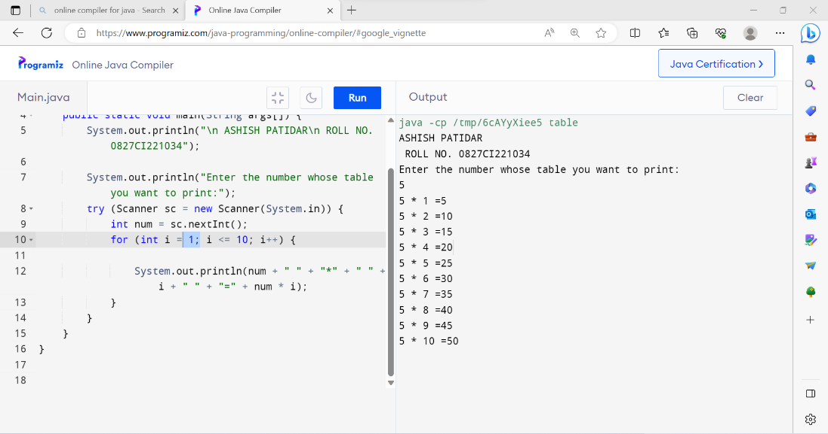

10. Display uppercased alphabet using for loop:-

publicclassa_z_alpha{

    publicstaticvoidmain(Stringargs[]) {

        System.out.println("\nASHISH PATIDAR\n ROLL NO. 0827CI221034");

        System.out.println("The uppercased alphabets are:");

        for (chari='A'; i<='Z'; i++) {

            System.out.println(i);

        }

    }

}

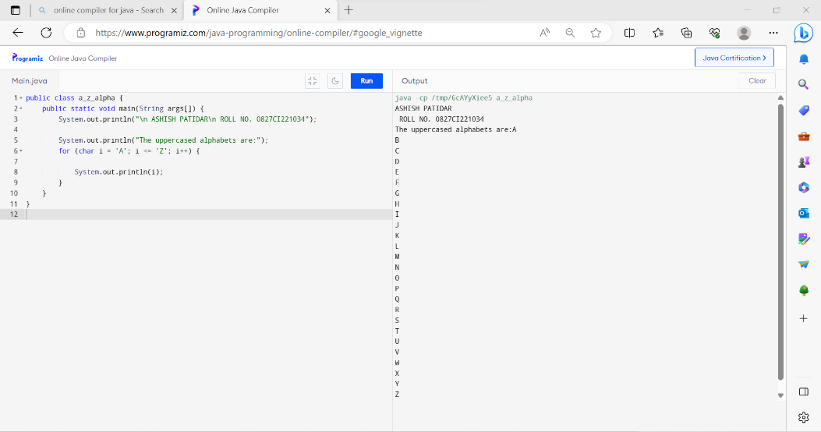

11. Find GCD of two numbers using for loop and if statement:-

importjava.util.Scanner;

publicclass G_C_D {

    publicstaticvoidmain(Stringargs[]) {

        System.out.println("\nASHISH PATIDAR\n ROLL NO. 0827CI221034");

        try (Scanner sc =newScanner(System.in)) {

            System.out.println("Enter any two numbers 1 : ");

            int a =sc.nextInt();

            System.out.println("Enter any two numbers 2 : ");

            int b =sc.nextInt();

            intgcd=1;

            for (inti=1; i<= a &&i<= b; i++) {

                if (a %i==0&& b %i==0) {

                    gcd=i;

                }

            }

            System.out.println("The GCD of the numbers is: "+gcd);

        }

    }

}

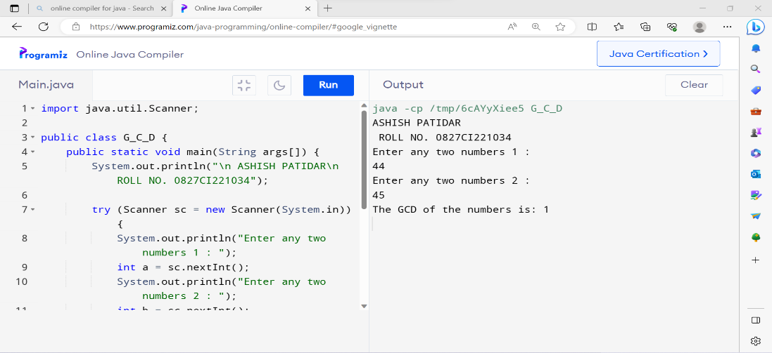

12. Program to find the reverse of a number:-

importjava.util.Scanner;

publicclassrevers_num{

    publicstaticvoidmain(Stringargs[]) {

        System.out.println("\nASHISH PATIDAR\n ROLL NO. 0827CI221034");

        System.out.println("Enter any number: ");

        try (Scanner sc =newScanner(System.in)) {

            int n =sc.nextInt();

            int rev =0;

            while (n >0) {

                int a = n %10;

                n = n /10;

                rev = (rev *10) + a;

            }

            System.out.println("The reversed number is: "+ rev);

        }

    }

}

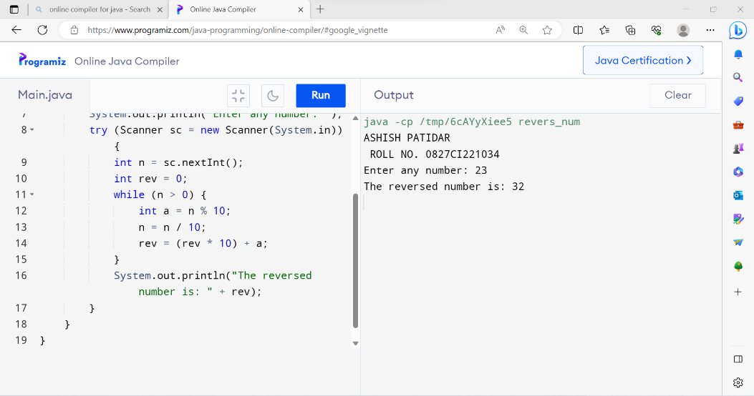

13.Demonstrate creating a class and Instance(object)

*// Java Program for class example*

class Student {

*// data member (also instance variable)*

    int id;

*// data member (also instance variable)*

    String name;

    publicstaticvoidmain(Stringargs[]) {

        System.out.println("\nASHISH PATIDAR\n ROLL NO. 0827CI221034");

*// creating an object of*

*// Student*

        Student s1 =newStudent();

        System.out.println(s1.id);

        System.out.println(s1.name);

    }

}

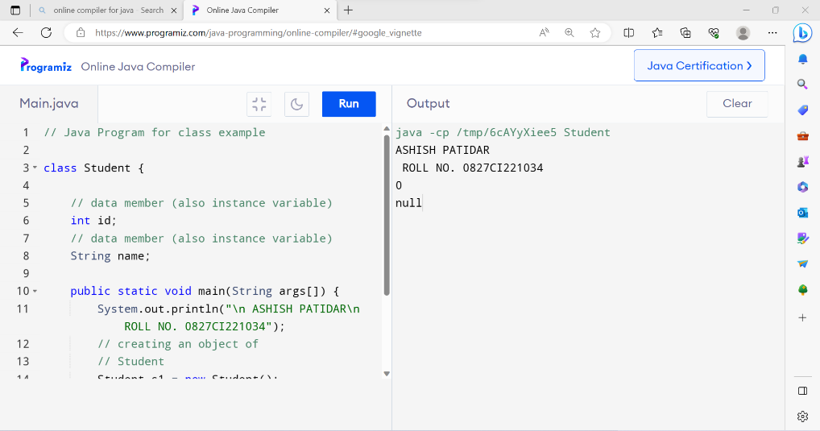

14.Demonstrate using Instance/class Variable in a Java Program by creating a simple public class

publicclassinstance_class

{

*/* declaration of instance variables. */*

    publicString name; *// public instance*

    String division; *// default instance*

    privateint age; *// private instance*

*/* Constructor that initialize an instance variable. */*

    publicinstance_class(Stringsname) {

        System.out.println("\nASHISH\n ROLL NO. 0827CI221034");

        name =sname;

    }

*/* Method to intialize an instance variable. */*

    publicvoidsetDiv(Stringsdiv) {

        division =sdiv;

    }

*/* Method to intialize an instance variable. */*

    publicvoidsetAge(int sage) {

        age = sage;

    }

*/* Method to display the values of instance variables. */*

    publicvoidprintstud() {

        System.out.println("Student Name: "+ name);

        System.out.println("Student Division: "+ division);

        System.out.println("Student Age: "+ age);

    }

*/* Driver Code */*

    publicstaticvoidmain(Stringargs[]) {

        instance_class s =newinstance_class("ASHISH PATIDAR. ");

        s.setAge(14);

        s.setDiv("B");

        s.printstud();

    }

}

1. Demonstrate the java class using getter setter method for accessing private data members
2. publicclassGetterSetterExample{
3. privateString name; *// private = restricted access*
4. *// System.out.println("\n ASHISH PATIDAR\n ROLL NO. 0827CI221034");*
5. *// Getter*
6. publicStringgetName() {
7. return name;
8. }
9. *// Setter*
10. publicvoidsetName(StringnewName) {
11. this.name=newName;
12. }
13. }

16. Demonstrate the use of static variable

*// Java program to demonstrate execution*

*// of static blocks and variables*

class Test {

*// static variable*

    staticint a =m1();

*// static block*

    static {

        System.out.println("\n ASHISH PATIDAR\n ROLL NO. 0827CI221034");

        System.out.println("Inside static block");

    }

*// static method*

    staticintm1() {

        System.out.println("from m1");

        return20;

    }

*// static method(main !!)*

    publicstaticvoidmain(String[] args) {

        System.out.println("Value of a : "+ a);

        System.out.println("from main");

    }

}

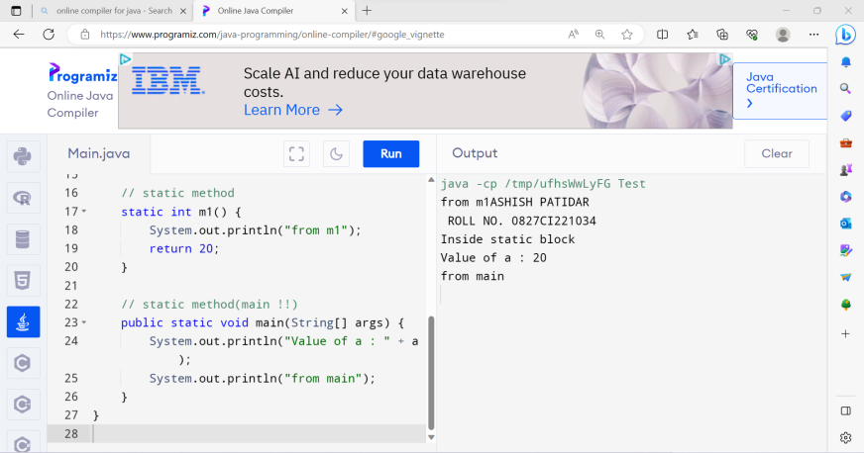

1. Demonstrate the use of Scanner class for taking input/output from user:-
2. import java.util.Scanner; // import the Scanner class
3. class Main {
4. public static void main(String[] args) {
5. Scanner myObj = new Scanner(System.in);
6. String userName;
7. // Enter username and press Enter
8. System.out.println("\nASHISH PATIDAR\n ROLL NO. 0827CI221034");
9. System.out.println("Enter username");
10. userName = myObj.nextLine();
11. System.out.println("Username is: " + userName);
12. }
13. }

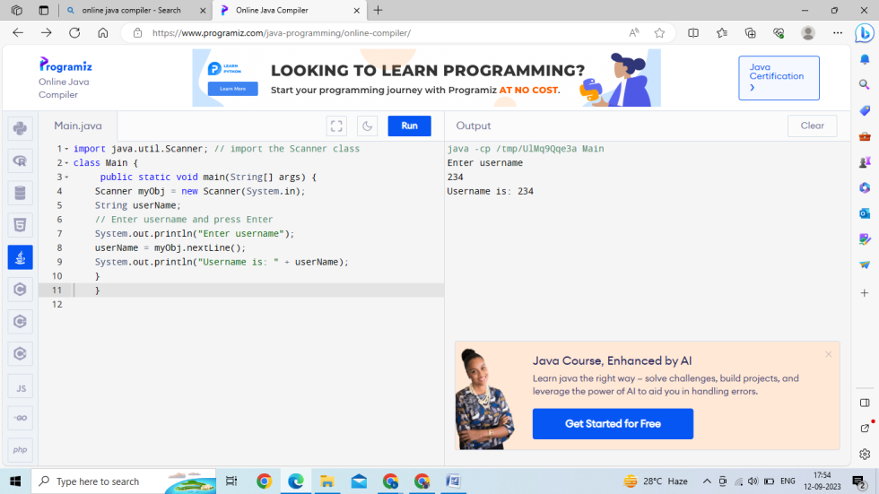

19. Light program:-

importjava.util.Scanner;

publicclass Light {

    booleanisOn;

    voidswitchOn() {

        isOn=true;

        System.out.println(isOn);

    }

    voidswitchOff() {

        isOn=false;

        System.out.println(isOn);

    }

    publicstaticvoidmain(Stringargs[]) {

        System.out.println("\nASHISH PATIDAR\n ROLL NO. 0827CI221034");

        Light led =newLight();

        Light halogen =newLight();

        led.switchOn();

        halogen.switchOff();

        System.out.println(led.isOn);

    }

}

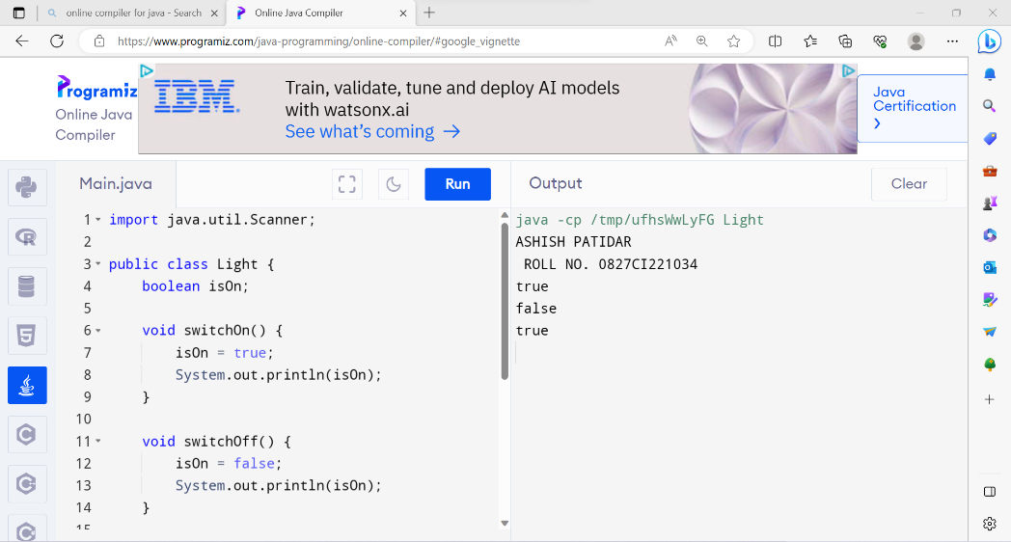

20. Box Program:-

publicclass Box {

    privateint height;

    privateint length;

    privateint breadth;

    Box() {

        height =0;

        length =0;

        breadth =0;

    }

    Box(int height, int length, int breadth) {

        this.height= height;

        this.length= length;

        this.breadth= breadth;

    }

    publicintVolume() {

        return (length * breadth * height);

    }

    publicstaticvoidmain(Stringargs[]) {

        Box cuboid1 =newBox();

        System.out.println("The area of the cuboid is"+

                cuboid1.Volume());

        Box cuboid2 =newBox(10, 15, 30);

        System.out.println("The area of cuboid is"+

                cuboid2.Volume());

    }

}

